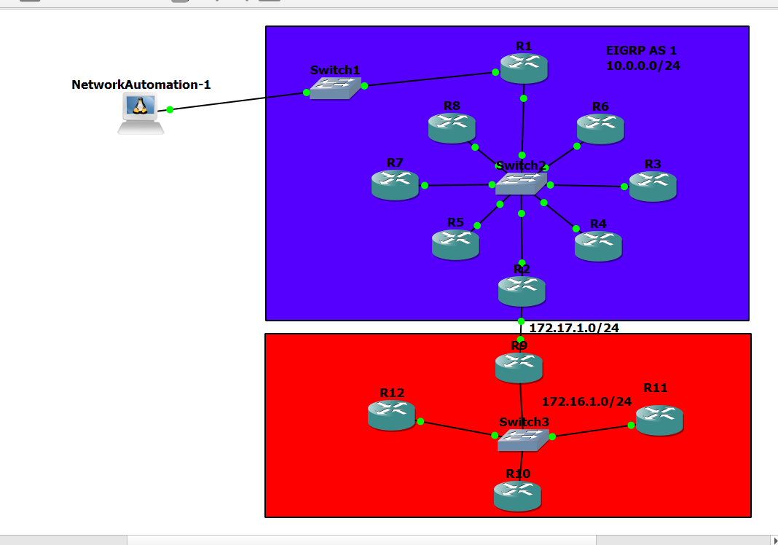

Network Topology

Blue area is the EIGRP area while the RED are is the RIPv2.

|  |  |  |  |
| --- | --- | --- | --- |
|  | Fa0/0 | Fa0/1 | Loopback Address |
| R1 | 192.168.1.1/24 | 10.0.0.1/24 | 1.1.1.1/32 |
| R2 | 10.0.0.2/24 | 172.17.1.1/24 |  |
| R3 | 10.0.0.3/24 |  |  |
| R4 | 10.0.0.4/24 |  |  |
| R5 | 10.0.0.5/24 |  |  |
| R6 | 10.0.0.6/24 |  |  |
| R7 | 10.0.0.7/24 |  |  |
| R8 | 10.0.0.8/24 |  |  |
| R9 | 172.17.1.2/24 | 172.16.1.1/24 |  |
| R10 | 172.16.1.2/24 |  |  |
| R11 | 172.16.1.3/24 |  |  |
| R12 | 172.16.1.4/24 |  |  |

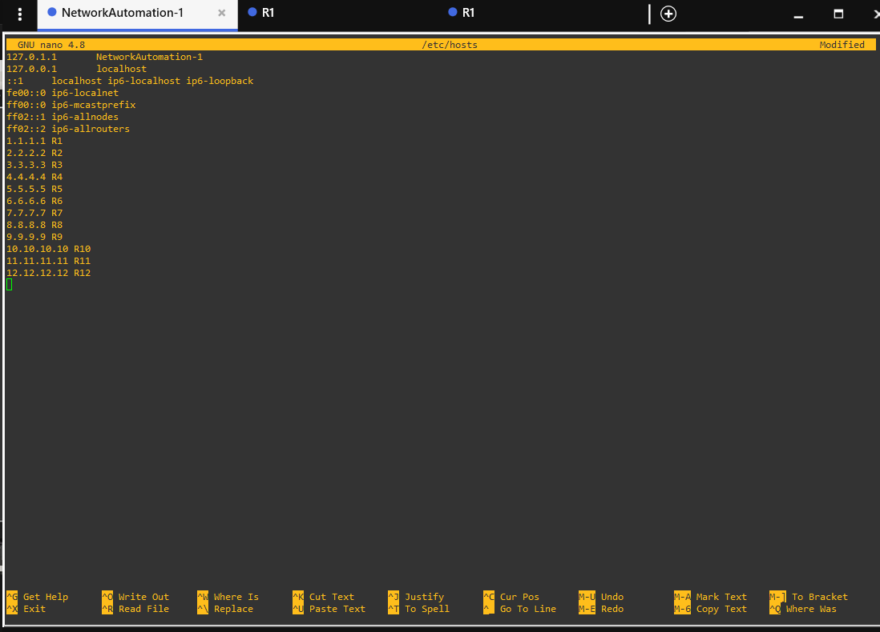

We typed nano /etc/hosts so that we can designate the loopback addresses to their router names so we can specify them easily later on.

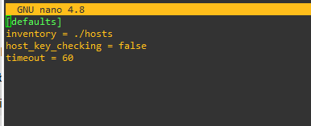

We configured ansible.cfg and inserted the following commands, the inventory for the hosts addresses and the host_key_checking for the rsa keys and the timeout 60 for the length of time that we can access all the routers from 1 to 12.

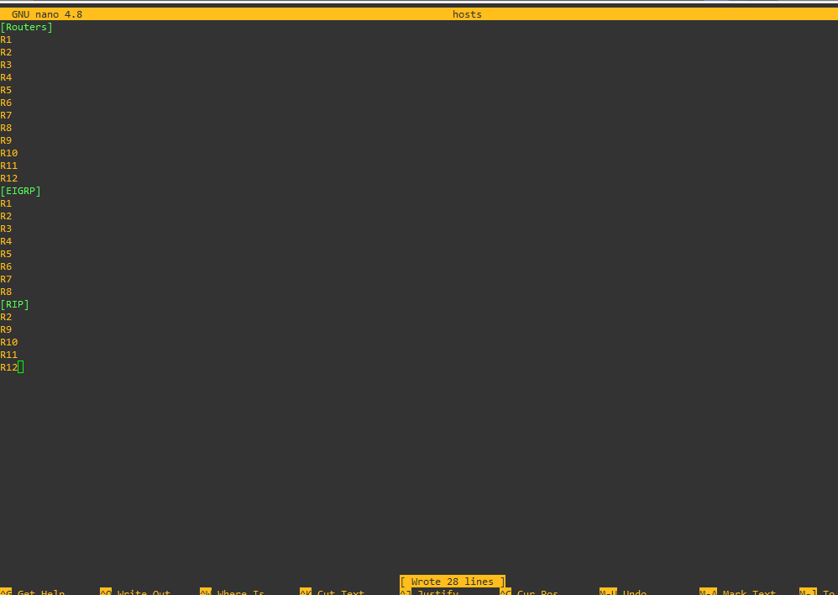

Finally we specified them in their specific groups.

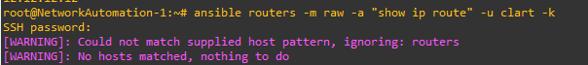

Unfortunately this error occurred, that’s why i was not able to show the ip routes of all the routers.

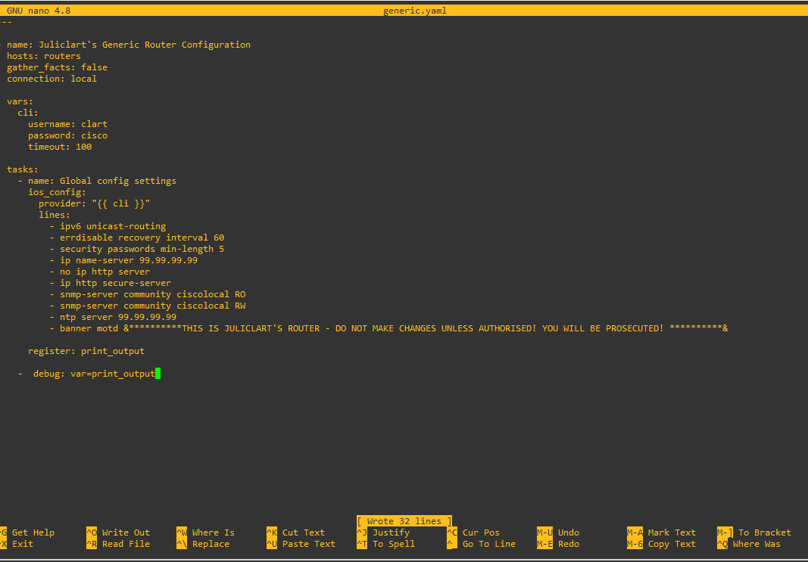

For continuation, here is our ansible-playbook that should be inserted into the configuration of the routers.

**Router Configurations:**

**R1:**

**R1#config t**

**Enter configuration commands, one per line. End with CNTL/Z.**

**R1(config)#config t**

**^**

**% Invalid input detected at '^' marker.**

**R1(config)#int loopback 0**

**R1(config-if)#ip add**

**\*Mar 1 00:02:40.571: %LINEPROTO-5-UPDOWN: Line protocol on Interface Loopback0, changed state to up**

**R1(config-if)#ip add 10.0.0.1 255.255.255.255**

**R1(config-if)#no shut**

**R1(config-if)#exit**

**R1(config)#int fa0/0**

**R1(config-if)#ip add 192.168.1.1 255.255.255.0**

**R1(config-if)#no shut**

**R1(config-if)#exit**

**\*Mar 1 00:03:23.283: %LINK-3-UPDOWN: Interface FastEthernet0/0, changed state to up**

**\*Mar 1 00:03:24.283: %LINEPROTO-5-UPDOWN: Line protocol on Interface FastEthernet0/0, changed state to up**

**R1(config-if)#exit**

**R1(config)#exit**

**R1#co**

**\*Mar 1 00:03:28.335: %SYS-5-CONFIG_I: Configured from console by console**

**R1#config t**

**Enter configuration commands, one per line. End with CNTL/Z.**

**R1(config)#enable secret cisco**

**R1(config)#service password-encryption**

**R1(config)#no ip domain lookup**

**R1(config)#line vty 0 4**

**R1(config-line)#login local**

**R1(config-line)#transport input ssh**

**R1(config-line)#exit**

**R1(config)#router eigrp 1**

**R1(config-router)#network 0.0.0.0**

**R1(config-router)#end**

**R1#**

**\*Mar 1 00:05:49.315: %SYS-5-CONFIG_I: Configured from console by console**

**R1#copy run start**

**Destination filename [startup-config]?**

**Building configuration...**

**[OK]**

**R1#**

**R1#config t**

**Enter configuration commands, one per line. End with CNTL/Z.**

**R1(config)#no int loopback 0**

**R1(config)#int loopb**

**\*Mar 1 00:09:35.683: %LINK-5-CHANGED: Interface Loopback0, changed state to administratively down**

**\*Mar 1 00:09:36.683: %LINEPROTO-5-UPDOWN: Line protocol on Interface Loopback0, changed state to down**

**R1(config)#int loopback 0**

**R1(config-if)#ip add**

**\*Mar 1 00:09:40.987: %LINK-3-UPDOWN: Interface Loopback0, changed state to up**

**\*Mar 1 00:09:41.987: %LINEPROTO-5-UPDOWN: Line protocol on Interface Loopback0, changed state to up**

**R1(config-if)#ip add 1.1.1.1 255.255.255.255**

**R1(config-if)#no shut**

**R1(config-if)#exit**

**R1(config)#end**

**R1#copy**

**\*Mar 1 00:09:52.635: %SYS-5-CONFIG_I: Configured from console by console**

**R1#copy run start**

**Destination filename [startup-config]?**

**Building configuration...**

**[OK]**

**R1#**

**R1#config t**

**Enter configuration commands, one per line. End with CNTL/Z.**

**R1(config)#router eigrp 1**

**R1(config-router)#no auto-summary**

**R1(config-router)#end**

**R1#cop**

**\*Mar 1 00:12:30.579: %SYS-5-CONFIG_I: Configured from console by console**

**R1#copy run start**

**Destination filename [startup-config]?**

**Building configuration...**

**[OK]**

**R1#config t**

**Enter configuration commands, one per line. End with CNTL/Z.**

**R1(config)#int fa0/1**

**R1(config-if)#ip add 10.0.0.1**

**% Incomplete command.**

**R1(config-if)#ip add 10.0.0.1 255.255.255.0**

**R1(config-if)#no shut**

**R1(config-if)#**

**\*Mar 1 00:14:27.639: %DUAL-5-NBRCHANGE: IP-EIGRP(0) 1: Neighbor 10.0.0.2 (FastEthernet0/1) is up: new adjacency**

**R1(config-if)#**

**\*Mar 1 00:14:28.055: %LINK-3-UPDOWN: Interface FastEthernet0/1, changed state to up**

**\*Mar 1 00:14:29.055: %LINEPROTO-5-UPDOWN: Line protocol on Interface FastEthernet0/1, changed state to up**

**R1(config-if)#exit**

**R1(config)#copy run start**

**^**

**% Invalid input detected at '^' marker.**

**R1(config)#end**

**R1#xo**

**\*Mar 1 00:14:44.179: %SYS-5-CONFIG_I: Configured from console by console**

**R1#copy run start**

**Destination filename [startup-config]?**

**Building configuration...**

**[OK]**

**R2#config t**

**Enter configuration commands, one per line. End with CNTL/Z.**

**R2(config)#enable secret cisco**

**R2(config)#service password encryption**

**^**

**% Invalid input detected at '^' marker.**

**R2(config)#service password-encryption**

**R2(config)#no ip domain-lookup**

**R2(config)#line vty 0 4**

**R2(config-line)#login local**

**R2(config-line)#transport input ssh**

**R2(config-line)#exit**

**R2(config)#int fa0/1**

**R2(config-if)#ip add 172.17.1.1 255.255.255.0**

**R2(config-if)#no shut**

**R2(config-if)#exit**

**\*Mar 1 00:05:07.007: %LINK-3-UPDOWN: Interface FastEthernet0/1, changed state to up**

**\*Mar 1 00:05:08.007: %LINEPROTO-5-UPDOWN: Line protocol on Interface FastEthernet0/1, changed state to up**

**R2(config-if)#exit**

**R2(config)#int loopback address 0**

**^**

**% Invalid input detected at '^' marker.**

**R2(config)#int loopback 0**

**R2(config-if)#ip add**

**\*Mar 1 00:05:24.383: %LINEPROTO-5-UPDOWN: Line protocol on Interface Loopback0, changed state to up**

**R2(config-if)#ip add 2.2.2.2 255.255.255.255**

**R2(config-if)#noshut**

**^**

**% Invalid input detected at '^' marker.**

**R2(config-if)#no shut**

**R2(config-if)#exit**

**R2(config)#router eigrp 1**

**R2(config-router)#network 0.0.0.0**

**R2(config-router)#network 172.17.1.0**

**R2(config-router)#no auto-summary**

**R2(config-router)#end**

**R2#copy ru**

**\*Mar 1 00:08:26.935: %SYS-5-CONFIG_I: Configured from console by console**

**R2#copy run start**

**Destination filename [startup-config]?**

**Building configuration...**

**[OK]**

**R2#**

**R3#config t**

**Enter configuration commands, one per line. End with CNTL/Z.**

**R3(config)#enable secret cisco**

**R3(config)#service password-encryption**

**R3(config)#no ip domain-lookup**

**R3(config)#int fa0/0**

**R3(config-if)#ip add 10.0.0.3 255.255.255.0**

**R3(config-if)#no shut**

**R3(config-if)#exit**

**R3(config)#int loopb**

**\*Mar 1 00:09:10.795: %LINK-3-UPDOWN: Interface FastEthernet0/0, changed state to up**

**\*Mar 1 00:09:11.795: %LINEPROTO-5-UPDOWN: Line protocol on Interface FastEthernet0/0, changed state to up**

**R3(config)#int loopback 0**

**R3(config-if)#3.3.33.**

**\*Mar 1 00:09:18.759: %LINEPROTO-5-UPDOWN: Line protocol on Interface Loopback0, changed state to up**

**R3(config-if)#ip add 3.3.3.3 255.255.255.0**

**R3(config-if)#exit**

**R3(config)#line vty 0 4**

**R3(config-line)#login local**

**R3(config-line)#transport input ssh**

**R3(config-line)#ip domain-name cisco.com**

**R3(config)#exit**

**R3#co**

**\*Mar 1 00:10:12.643: %SYS-5-CONFIG_I: Configured from console by console**

**R3#copy run start**

**Destination filename [startup-config]?**

**Building configuration...**

**[OK]**

**R3#config t**

**Enter configuration commands, one per line. End with CNTL/Z.**

**R3(config)#router eigrp 1**

**R3(config-router)#network 0.0.0.0**

**R3(config-router)#e**

**\*Mar 1 00:10:33.603: %DUAL-5-NBRCHANGE: IP-EIGRP(0) 1: Neighbor 10.0.0.2 (FastEthernet0/0) is up: new adjacency**

**\*Mar 1 00:10:33.607: %DUAL-5-NBRCHANGE: IP-EIGRP(0) 1: Neighbor 10.0.0.1 (FastEthernet0/0) is up: new adjacency**

**R3(config-router)#exit**

**R3(config)#end**

**R3#cop**

**\*Mar 1 00:10:39.403: %SYS-5-CONFIG_I: Configured from console by console**

**R3#copy run start**

**Destination filename [startup-config]?**

**Building configuration...**

**[OK]**

**R3#**

**R4#**

**R4#config t**

**Enter configuration commands, one per line. End with CNTL/Z.**

**R4(config)#enable secret cisco**

**R4(config)#service password-encryption**

**R4(config)#no ip domain-lookup**

**R4(config)#int fa0/0**

**R4(config-if)#ip add 10.0.0.4 255.255.255.0**

**R4(config-if)#no shut**

**R4(config-if)#exit**

**R4(config)#**

**\*Mar 1 00:11:20.747: %LINK-3-UPDOWN: Interface FastEthernet0/0, changed state to up**

**\*Mar 1 00:11:21.747: %LINEPROTO-5-UPDOWN: Line protocol on Interface FastEthernet0/0, changed state to up**

**R4(config)#int loopback 0**

**R4(config-if)#ip add**

**\*Mar 1 00:11:25.843: %LINEPROTO-5-UPDOWN: Line protocol on Interface Loopback0, changed state to up**

**R4(config-if)#ip add 4.4.4.4 255.255.255.255**

**R4(config-if)#exit**

**R4(config)#line vty 0 4**

**R4(config-line)#login local**

**R4(config-line)#transport input ssh**

**R4(config-line)#ip domain-name cisco.com**

**R4(config)#exit**

**R4#**

**\*Mar 1 00:12:08.911: %SYS-5-CONFIG_I: Configured from console by console**

**R4#config t**

**Enter configuration commands, one per line. End with CNTL/Z.**

**R4(config)#router eigrp 1**

**R4(config-router)#network 0.0.0.0**

**R4(config-router)#**

**\*Mar 1 00:12:30.439: %DUAL-5-NBRCHANGE: IP-EIGRP(0) 1: Neighbor 10.0.0.3 (FastEthernet0/0) is up: new adjacency**

**\*Mar 1 00:12:30.439: %DUAL-5-NBRCHANGE: IP-EIGRP(0) 1: Neighbor 10.0.0.2 (FastEthernet0/0) is up: new adjacency**

**\*Mar 1 00:12:30.443: %DUAL-5-NBRCHANGE: IP-EIGRP(0) 1: Neighbor 10.0.0.1 (FastEthernet0/0) is up: new adjacency**

**R4(config-router)#exit**

**R4(config)#end**

**R4#copy**

**\*Mar 1 00:12:37.703: %SYS-5-CONFIG_I: Configured from console by console**

**R4#copy run start**

**Destination filename [startup-config]?**

**Building configuration...**

**[OK]**

**R4#**

**R5(config)#enable secret cisco**

**R5(config)#service password-encryption**

**R5(config)#no ip domain lookup**

**R5(config)#int fa0/0**

**R5(config-if)#ip add 10.0.0.5 255.255.255.0**

**R5(config-if)#no shut**

**R5(config-if)#exit**

**R5(config)#int loop**

**\*Mar 1 00:13:13.787: %LINK-3-UPDOWN: Interface FastEthernet0/0, changed state to up**

**\*Mar 1 00:13:14.787: %LINEPROTO-5-UPDOWN: Line protocol on Interface FastEthernet0/0, changed state to up**

**R5(config)#int loopback 0**

**R5(config-if)#ip add 5**

**\*Mar 1 00:13:20.355: %LINEPROTO-5-UPDOWN: Line protocol on Interface Loopback0, changed state to up**

**R5(config-if)#ip add 5.5.5.5 255.255.255.255**

**R5(config-if)#exit**

**R5(config)#line vty 0 4**

**R5(config-line)#login local**

**R5(config-line)#transport input ssh**

**R5(config-line)#ip domaine-name cisco**

**^**

**% Invalid input detected at '^' marker.**

**R5(config-line)#ip domain-name cisco.com**

**R5(config)#exit**

**R5#confi**

**\*Mar 1 00:14:07.879: %SYS-5-CONFIG_I: Configured from console by console**

**R5#conf t**

**Enter configuration commands, one per line. End with CNTL/Z.**

**R5(config)#router eigrp 1**

**R5(config-router)#network 0.0.0.0**

**R5(config-router)#**

**\*Mar 1 00:14:20.571: %DUAL-5-NBRCHANGE: IP-EIGRP(0) 1: Neighbor 10.0.0.4 (FastEthernet0/0) is up: new adjacency**

**\*Mar 1 00:14:20.575: %DUAL-5-NBRCHANGE: IP-EIGRP(0) 1: Neighbor 10.0.0.3 (FastEthernet0/0) is up: new adjacency**

**\*Mar 1 00:14:20.575: %DUAL-5-NBRCHANGE: IP-EIGRP(0) 1: Neighbor 10.0.0.2 (FastEthernet0/0) is up: new adjacency**

**\*Mar 1 00:14:20.579: %DUAL-5-NBRCHANGE: IP-EIGRP(0) 1: Neighbor 10.0.0.1 (FastEthernet0/0) is up: new adjacency**

**R5(config-router)#exit**

**R5(config)#end**

**R5#copy ru**

**\*Mar 1 00:14:25.915: %SYS-5-CONFIG_I: Configured from console by console**

**R5#copy run start**

**Destination filename [startup-config]?**

**Building configuration...**

**[OK]**

**R5#**

**R5#**

**R6#conf t**

**Enter configuration commands, one per line. End with CNTL/Z.**

**R6(config)#enable secret cisco**

**R6(config)#service password encryption**

**^**

**% Invalid input detected at '^' marker.**

**R6(config)#service password-encryption**

**R6(config)#no ip domain-lookup**

**R6(config)#int fa0/0**

**R6(config-if)#10.0.0.6 255.255.255.0**

**^**

**% Invalid input detected at '^' marker.**

**R6(config-if)#ip add 10.0.0.6 255.255.255.0**

**R6(config-if)#no shut**

**R6(config-if)#exit**

**R6(config)#int loop**

**\*Mar 1 00:14:26.839: %LINK-3-UPDOWN: Interface FastEthernet0/0, changed state to up**

**\*Mar 1 00:14:27.839: %LINEPROTO-5-UPDOWN: Line protocol on Interface FastEthernet0/0, changed state to up**

**R6(config)#int loopback 0**

**R6(config-if)#ip**

**\*Mar 1 00:14:31.203: %LINEPROTO-5-UPDOWN: Line protocol on Interface Loopback0, changed state to up**

**R6(config-if)#ip add 6.6.6.6 255.255.255.255**

**R6(config-if)#exit**

**R6(config)#line vty 0 4**

**R6(config-line)#login local**

**R6(config-line)#transport input ssh**

**R6(config-line)#ip domain-name cisco.com**

**R6(config)#exit**

**R6#**

**\*Mar 1 00:15:07.827: %SYS-5-CONFIG_I: Configured from console by console**

**R6#copy run start**

**Destination filename [startup-config]?**

**Building configuration...**

**[OK]**

**R6#conf t**

**Enter configuration commands, one per line. End with CNTL/Z.**

**R6(config)#router eigrp 1**

**R6(config-router)#network 0.0.0.0**

**R6(config-router)#end**

**R6#**

**\*Mar 1 00:15:33.431: %DUAL-5-NBRCHANGE: IP-EIGRP(0) 1: Neighbor 10.0.0.4 (FastEthernet0/0) is up: new adjacency**

**\*Mar 1 00:15:33.435: %DUAL-5-NBRCHANGE: IP-EIGRP(0) 1: Neighbor 10.0.0.1 (FastEthernet0/0) is up: new adjacency**

**\*Mar 1 00:15:33.439: %DUAL-5-NBRCHANGE: IP-EIGRP(0) 1: Neighbor 10.0.0.3 (FastEthernet0/0) is up: new adjacency**

**\*Mar 1 00:15:33.439: %DUAL-5-NBRCHANGE: IP-EIGRP(0) 1: Neighbor 10.0.0.2 (FastEthernet0/0) is up: new adjacency**

**\*Mar 1 00:15:33.443: %DUAL-5-NBRCHANGE: IP-EIGRP(0) 1: Neighbor 10.0.0.5 (FastEthernet0/0) is up: new adjacency**

**R6#**

**\*Mar 1 00:15:34.863: %SYS-5-CONFIG_I: Configured from console by console**

**R6#copy run start**

**Destination filename [startup-config]?**

**Building configuration...**

**[OK]**

**R6#ping 1.1.1.1**

**Type escape sequence to abort.**

**Sending 5, 100-byte ICMP Echos to 1.1.1.1, timeout is 2 seconds:**

**!!!!!**

**R7#conf t**

**Enter configuration commands, one per line. End with CNTL/Z.**

**R7(config)#enable secret cisco**

**R7(config)#service password-encryption**

**R7(config)#no ip domain-lookup**

**R7(config)#int fa0/0**

**R7(config-if)#ip add 10.0.0.7 255.255.255.0**

**R7(config-if)#no shut**

**R7(config-if)#exit**

**R7(config)#**

**\*Mar 1 00:16:11.983: %LINK-3-UPDOWN: Interface FastEthernet0/0, changed state to up**

**\*Mar 1 00:16:12.983: %LINEPROTO-5-UPDOWN: Line protocol on Interface FastEthernet0/0, changed state to up**

**R7(config)#int loopback 0**

**R7(config-if)#**

**\*Mar 1 00:16:17.171: %LINEPROTO-5-UPDOWN: Line protocol on Interface Loopback0, changed state to up**

**R7(config-if)#ip add 7.7.7.7 255.255.255.255**

**R7(config-if)#exit**

**R7(config)#line vty 0 4**

**R7(config-line)#login local**

**R7(config-line)#transport input ssh**

**R7(config-line)#ip domain-name cisco.com**

**R7(config)#exit**

**R7#co**

**\*Mar 1 00:16:49.759: %SYS-5-CONFIG_I: Configured from console by console**

**R7#conf t**

**Enter configuration commands, one per line. End with CNTL/Z.**

**R7(config)#router eigrp 1**

**R7(config-router)#network 0.0.0.0**

**R7(config-router)#**

**\*Mar 1 00:17:01.563: %DUAL-5-NBRCHANGE: IP-EIGRP(0) 1: Neighbor 10.0.0.6 (FastEthernet0/0) is up: new adjacency**

**\*Mar 1 00:17:01.567: %DUAL-5-NBRCHANGE: IP-EIGRP(0) 1: Neighbor 10.0.0.5 (FastEthernet0/0) is up: new adjacency**

**\*Mar 1 00:17:01.567: %DUAL-5-NBRCHANGE: IP-EIGRP(0) 1: Neighbor 10.0.0.4 (FastEthernet0/0) is up: new adjacency**

**\*Mar 1 00:17:01.567: %DUAL-5-NBRCHANGE: IP-EIGRP(0) 1: Neighbor 10.0.0.3 (FastEthernet0/0) is up: new adjacency**

**\*Mar 1 00:17:01.567: %DUAL-5-NBRCHANGE: IP-EIGRP(0) 1: Neighbor 10.0.0.1 (FastEthernet0/0) is up: new adjacency**

**\*Mar 1 00:17:01.567: %DUAL-5-NBRCHANGE: IP-EIGRP(0) 1: Neighbor 10.0.0.2 (FastEthernet0/0) is up: new adjacency**

**R7(config-router)#end**

**R7#copy ru**

**\*Mar 1 00:17:11.407: %SYS-5-CONFIG_I: Configured from console by console**

**R7#copy run start**

**Destination filename [startup-config]?**

**Building configuration...**

**R8#conf t**

**Enter configuration commands, one per line. End with CNTL/Z.**

**R8(config)#enable secret cisco**

**R8(config)#service password-encryption**

**R8(config)#no ip domain-lookup**

**R8(config)#int fa0/0**

**R8(config-if)#ip add 10.0.0.8 255.255.255.0**

**R8(config-if)#no shut**

**R8(config-if)#exit**

**R8(config)#int loopback**

**\*Mar 1 00:17:27.971: %LINK-3-UPDOWN: Interface FastEthernet0/0, changed state to up**

**\*Mar 1 00:17:28.971: %LINEPROTO-5-UPDOWN: Line protocol on Interface FastEthernet0/0, changed state to up**

**R8(config)#int loopback 0**

**R8(config-if)#**

**\*Mar 1 00:17:31.467: %LINEPROTO-5-UPDOWN: Line protocol on Interface Loopback0, changed state to up**

**R8(config-if)#ip add 8.8.8.8 255.255.255.255**

**R8(config-if)#exit**

**R8(config)#line vty 0 4**

**R8(config-line)#login local**

**R8(config-line)#transport input ssh**

**R8(config-line)#ip domain-name cisco.com**

**R8(config)#exit**

**R8#conf**

**\*Mar 1 00:18:29.263: %SYS-5-CONFIG_I: Configured from console by console**

**R8#conf t**

**Enter configuration commands, one per line. End with CNTL/Z.**

**R8(config)#router eigrp 1**

**R8(config-router)#network 0.0.0.0**

**R8(config-router)#**

**\*Mar 1 00:18:44.695: %DUAL-5-NBRCHANGE: IP-EIGRP(0) 1: Neighbor 10.0.0.7 (FastEthernet0/0) is up: new adjacency**

**\*Mar 1 00:18:44.695: %DUAL-5-NBRCHANGE: IP-EIGRP(0) 1: Neighbor 10.0.0.5 (FastEthernet0/0) is up: new adjacency**

**\*Mar 1 00:18:44.699: %DUAL-5-NBRCHANGE: IP-EIGRP(0) 1: Neighbor 10.0.0.4 (FastEthernet0/0) is up: new adjacency**

**\*Mar 1 00:18:44.699: %DUAL-5-NBRCHANGE: IP-EIGRP(0) 1: Neighbor 10.0.0.2 (FastEthernet0/0) is up: new adjacency**

**\*Mar 1 00:18:44.719: %DUAL-5-NBRCHANGE: IP-EIGRP(0) 1: Neighbor 10.0.0.6 (FastEthernet0/0) is up: new adjacency**

**\*Mar 1 00:18:44.719: %DUAL-5-NBRCHANGE: IP-EIGRP(0) 1: Neighbor 10.0.0.3 (FastEthernet0/0) is up: new adjacency**

**R8(config-router)#**

**\*Mar 1 00:18:44.719: %DUAL-5-NBRCHANGE: IP-EIGRP(0) 1: Neighbor 10.0.0.1 (FastEthernet0/0) is up: new adjacency**

**R8(config-router)#exit**

**R8(config)#end**

**R8#copy**

**\*Mar 1 00:18:49.651: %SYS-5-CONFIG_I: Configured from console by console**

**R8#copy run start**

**Destination filename [startup-config]?**

**Building configuration...**

**[OK]**

**R8#**

**R9#**

**R9#config t**

**Enter configuration commands, one per line. End with CNTL/Z.**

**R9(config)#enable secret cisco**

**R9(config)#service password-encryption**

**R9(config)#no ip domain-lookup**

**R9(config)#int fa0/0**

**R9(config-if)#ip add 172.17.1.2 255.255.255.0**

**R9(config-if)#nop shut**

**^**

**% Invalid input detected at '^' marker.**

**R9(config-if)#no shut**

**R9(config-if)#exit**

**R9(config)#int**

**\*Mar 1 00:21:33.903: %LINK-3-UPDOWN: Interface FastEthernet0/0, changed state to up**

**\*Mar 1 00:21:34.903: %LINEPROTO-5-UPDOWN: Line protocol on Interface FastEthernet0/0, changed state to up**

**R9(config)#int fa0/1**

**R9(config-if)#ip add 172.16.1.2 255.255.255.0**

**R9(config-if)#no shut**

**R9(config-if)#exit**

**R9(config)#int**

**\*Mar 1 00:22:00.983: %LINK-3-UPDOWN: Interface FastEthernet0/1, changed state to up**

**\*Mar 1 00:22:01.983: %LINEPROTO-5-UPDOWN: Line protocol on Interface FastEthernet0/1, changed state to up**

**R9(config)#int loopback 0**

**R9(config-if)#**

**\*Mar 1 00:22:05.559: %LINEPROTO-5-UPDOWN: Line protocol on Interface Loopback0, changed state to up**

**R9(config-if)#ip add 9.9.9.9 255.255.255.255**

**R9(config-if)#exit**

**R9(config)#line vty 0 4**

**R9(config-line)#enable secret cisco**

**R9(config)#line vty 0 4**

**R9(config-line)#login local**

**R9(config-line)#transport input ssh**

**R9(config-line)#ip domain-name cisco.com**

**R9(config)#exit**

**R9#co**

**\*Mar 1 00:23:22.395: %SYS-5-CONFIG_I: Configured from console by console**

**R9#conf t**

**Enter configuration commands, one per line. End with CNTL/Z.**

**R9(config)#router eigrp 1**

**R9(config-router)#network 172.17.1.0**

**R9(config-router)#netw**

**\*Mar 1 00:23:42.751: %DUAL-5-NBRCHANGE: IP-EIGRP(0) 1: Neighbor 172.17.1.1 (FastEthernet0/0) is up: new adjacency**

**R9(config-router)#network 0.0.0.0**

**R9(config-router)#exit**

**R9(config)#end**

**R9#copy**

**\*Mar 1 00:24:05.495: %SYS-5-CONFIG_I: Configured from console by console**

**R9#copy run start**

**Destination filename [startup-config]?**

**Building configuration...**

**[OK]**

**R9#**

**R10#**

**R10#conf t**

**Enter configuration commands, one per line. End with CNTL/Z.**

**R10(config)#enable secret cisco**

**R10(config)#service password-encryption**

**R10(config)#no ip domain-lookup**

**R10(config)#int fa0/0**

**R10(config-if)#ip add 172.16.1.2 255.255.255.0**

**R10(config-if)#no shut**

**R10(config-if)#exit**

**R10(config)#int**

**\*Mar 1 00:24:45.527: %LINK-3-UPDOWN: Interface FastEthernet0/0, changed state to up**

**\*Mar 1 00:24:46.527: %LINEPROTO-5-UPDOWN: Line protocol on Interface FastEthernet0/0, changed state to up**

**R10(config)#int loopback 0**

**R10(config-if)#ip**

**\*Mar 1 00:24:51.747: %LINEPROTO-5-UPDOWN: Line protocol on Interface Loopback0, changed state to up**

**R10(config-if)#ip add 10.10.10.10 255.255.255.255**

**R10(config-if)#exit**

**R10(config)#line vty**

**% Incomplete command.**

**R10(config)#line vty 0 4**

**R10(config-line)#login local**

**R10(config-line)#transport input ssh**

**R10(config-line)#ip domain-name cisco.com**

**R10(config)#exit**

**R10#ro**

**\*Mar 1 00:25:54.079: %SYS-5-CONFIG_I: Configured from console by console**

**R10#conf t**

**Enter configuration commands, one per line. End with CNTL/Z.**

**R10(config)#router eigrp 1**

**R10(config-router)#network 0.0.0.0**

**R10(config-router)#**

**\*Mar 1 00:26:07.015: %DUAL-5-NBRCHANGE: IP-EIGRP(0) 1: Neighbor 172.16.1.1 (FastEthernet0/0) is up: new adjacency**

**R10(config-router)#end**

**R10#copy**

**\*Mar 1 00:26:18.787: %SYS-5-CONFIG_I: Configured from console by console**

**R10#copy run start**

**Destination filename [startup-config]?**

**Building configuration...**

**[OK]**

**R10#**

**R11#conf t**

**Enter configuration commands, one per line. End with CNTL/Z.**

**R11(config)#enable secret cisco**

**R11(config)#service password-encryption**

**R11(config)#no ip domain-lookup**

**R11(config)#int fa0/0**

**R11(config-if)#ip add 172.16.1.3 255.255.255.0**

**R11(config-if)#no shut**

**R11(config-if)#exit**

**R11(config)#int loopb**

**\*Mar 1 00:25:45.811: %LINK-3-UPDOWN: Interface FastEthernet0/0, changed state to up**

**\*Mar 1 00:25:46.811: %LINEPROTO-5-UPDOWN: Line protocol on Interface FastEthernet0/0, changed state to up**

**R11(config)#int loopback 0**

**R11(config-if)#i**

**\*Mar 1 00:25:49.835: %LINEPROTO-5-UPDOWN: Line protocol on Interface Loopback0, changed state to up**

**R11(config-if)#ip add 11.11.11.11 255.255.255.0**

**R11(config-if)#no ip add 11.11.11.11 255.255.255.0**

**R11(config-if)#ip add 11.11.11.11 255.255.255.255**

**R11(config-if)#exit**

**R11(config)#line vty 0 4**

**R11(config-line)#login local**

**R11(config-line)#transport input shh**

**^**

**% Invalid input detected at '^' marker.**

**R11(config-line)#transport input ssh**

**R11(config-line)#ip domain-name cisco.com**

**R11(config)#exit**

**R11#roue**

**\*Mar 1 00:26:41.751: %SYS-5-CONFIG_I: Configured from console by console**

**R11#conf t**

**Enter configuration commands, one per line. End with CNTL/Z.**

**R11(config)#router eigrp 1**

**R11(config-router)#network 0.0.0.0**

**R11(config-router)#**

**\*Mar 1 00:26:55.123: %DUAL-5-NBRCHANGE: IP-EIGRP(0) 1: Neighbor 172.16.1.2 (FastEthernet0/0) is up: new adjacency**

**\*Mar 1 00:26:55.123: %DUAL-5-NBRCHANGE: IP-EIGRP(0) 1: Neighbor 172.16.1.1 (FastEthernet0/0) is up: new adjacency**

**R11(config-router)#exit**

**R11(config)#copy run start**

**^**

**% Invalid input detected at '^' marker.**

**R11(config)#end**

**R11#cop**

**\*Mar 1 00:27:05.407: %SYS-5-CONFIG_I: Configured from console by console**

**R11#copy run start**

**Destination filename [startup-config]?**

**Building configuration...**

**[OK]**

**R11#**

**inistratively down**

**R12#**

**R12#conf t**

**Enter configuration commands, one per line. End with CNTL/Z.**

**R12(config)#enable secret cisco**

**R12(config)#service password-encryption**

**R12(config)#ip domain-lookup**

**R12(config)#no ip domain-lookup**

**R12(config)#int fa0/0**

**R12(config-if)#ip add 172.16.1.4 255.255.255.0**

**R12(config-if)#no shut**

**R12(config-if)#exit**

**R12(config)#int loo**

**\*Mar 1 00:27:26.615: %LINK-3-UPDOWN: Interface FastEthernet0/0, changed state to up**

**\*Mar 1 00:27:27.615: %LINEPROTO-5-UPDOWN: Line protocol on Interface FastEthernet0/0, changed state to up**

**R12(config)#int loopback 0**

**R12(config-if)#ip ad**

**\*Mar 1 00:27:31.295: %LINEPROTO-5-UPDOWN: Line protocol on Interface Loopback0, changed state to up**

**R12(config-if)#ip add 12.12.12.12 255.255.255.255**

**R12(config-if)#exit**

**R12(config)#line vty 0 4**

**R12(config-line)#login loca**

**R12(config-line)#transport input ssh**

**R12(config-line)#ip domain-name cisco.com**

**R12(config)#exit**

**R12#conf**

**\*Mar 1 00:28:21.899: %SYS-5-CONFIG_I: Configured from console by console**

**R12#conf t**

**Enter configuration commands, one per line. End with CNTL/Z.**

**R12(config)#router eigrp 1**

**R12(config-router)#network 0.0.0.0**

**R12(config-router)#**

**\*Mar 1 00:28:33.067: %DUAL-5-NBRCHANGE: IP-EIGRP(0) 1: Neighbor 172.16.1.3 (FastEthernet0/0) is up: new adjacency**

**\*Mar 1 00:28:33.067: %DUAL-5-NBRCHANGE: IP-EIGRP(0) 1: Neighbor 172.16.1.2 (FastEthernet0/0) is up: new adjacency**

**\*Mar 1 00:28:33.071: %DUAL-5-NBRCHANGE: IP-EIGRP(0) 1: Neighbor 172.16.1.1 (FastEthernet0/0) is up: new adjacency**

**R12(config-router)#end**

**R12#co**

**\*Mar 1 00:28:35.795: %SYS-5-CONFIG_I: Configured from console by console**

**R12#copy run start**

**Destination filename [startup-config]?**

**Building configuration...**

**[OK]**

**R12#exit**